Official league roster - Basketball
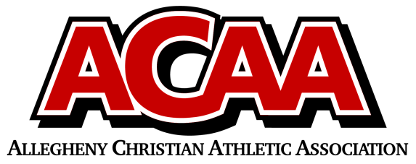

School Name: HCA
Team Colors: Green/Gold
Overall Wins____ Losses ____ Ties ____
ACAA Wins ____ Losses ____ Ties ____ OPPONENT: __________________________________
Date: _____________________
Number | Name | Year | Position | Height | Homeschool
13 | Ethan Ginther | 10 | g
30 | Jacob McCarty | 9 | f
31 | Raymond Kurtz | 10 | f
32 | Mark Harven | 10 | f
33 | Henry Morningstar | 9 | g
34 | Christian Sipes | 11 | g
35 | Owen Peachey | 12 | g

Head Coach: Steve Guisler
Asst. coach:
Asst. coach:

Official ACAA League Team Roster. to be submitted to the scorer’s table before each game.

